1. CONTENTS OF PAPER

The paper should contain:

- Title
- Author's details including affiliation and country
- Executive summary (of maximum 250 words, plain text)
- Maximum 5 keywords

Items 1-4 will be submitted through the menus and text boxes in the online submission form.

- Introduction
- Body of the paper, including tables and figures
- Acknowledgements, where appropriate
- Bibliography & reference(s), where appropriate

The submitted doc(x) file MUST ONLY contain items 5-8.

The paper should not be overtly commercial, should not use brand or trade names and should not be solely aimed at product promotion. Claims about product or process performance should be supported by factual and relevant information.

Submitted papers must be original. Papers previously published or presented in any form cannot be submitted.

Papers must contribute to the overarching theme of the Congress “Resilience. Sustainability. Innovation.” by falling in (at least) one of the fields listed below:

- Asphalt mixture performance and testing
- Binder performance and testing
- Digitalisation & Asphalt 4.0
- Environment
- Future roads and mobility
- Health & Safety
- Maintenance and rehabilitation
- Procurement and funding
- Production and construction equipment
- Resilience
- Sustainability
- Training, career development and industry attractiveness
- Warm and cold technologies

2. LANGUAGE OF PAPER

The paper must be submitted in English (American or British usage is accepted, but not a mixture of these). When describing materials, please use consistent, European terminology such as “bitumen” or “bituminous binder” for the binder and “asphalt” for the mixture.

Define abbreviations that are not standard in brackets at their first mention. Ensure consistency of abbreviations throughout the article.

3. LENGTH OF THE PAPER

The doc(x) file containing the items 5-8 must be no longer than 12 A4 pages (including pictures, tables and graphs).

The maximum size of the uploaded doc(x) file is 20 MB.

4. SECTION TEXT AND FORMATTING

Papers must be written in the same format as the present template. The top page margin must be set as 3 cm. Left, right and bottom page margins must be set as 2 cm. The page size must be A4. Use single-line spacing throughout the document.

Section titles must be capitalised, 10 point size, font style Arial Bold, left-aligned and numbered. Paragraphs must be separated by a single-spaced, 10 point line.

The text must be separated from the previous title by a single-spaced, 10 point line. Body text should be Times New Roman, 10 point size.

Sub-section text

Sub-section title should be Times New Roman Bold, 10 point size. Sub-section body text should be Times New Roman, 10 point size, block justified. Single-line spacing between paragraphs and sections.

5. TABLES AND FIGURES

Tables and figures (including the captions) must follow the format of the example Table 1 and Figure 1.

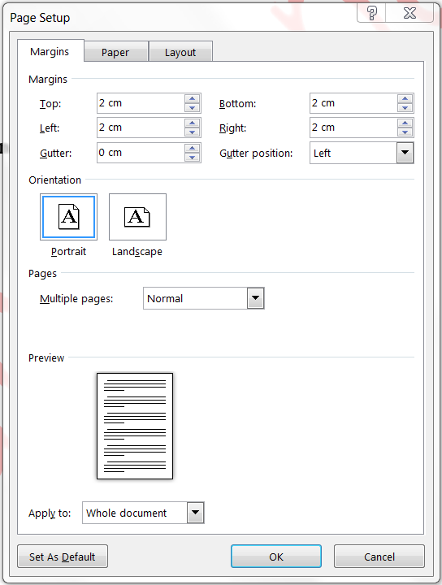
Figure 1: Title below figure, both figure and title centred

Table 1. Table title above table, both table and title centred
Column 1 | Column 2 | Column 3 | Column 4
Text | value | value | value
etc

6. ACKNOWLEDGEMENTS

Acknowledgements must be collated in a separate section at the end of the article and before the references. Please make sure all those individuals who provided help and funding during the research are listed here.

7. REFERENCES

Indicate references by number(s) in square brackets in line with the text, as can be seen in the following examples:
'....the use was studied in [1]. Ding et al. [1] also investigated at laboratory level the performance of recycled asphalt concrete....'

List the references with the respective numbers in square brackets and in the order in which they appear in the text, at the end of the manuscript. References must contain authors’ names, article title, publication title, volume, publication year, pages and DOI, as shown in the following example:

[1] X Ding, L Chen, T Ma, H Ma, L Gu, T Chen, Y Ma. Laboratory investigation of the recycled asphalt concrete with stable crumb rubber asphalt binder. Construction and Building Materials 203 (2019) 552-557. https://doi.org/10.1016/j.conbuildmat.2019.01.114

8. COPYRIGHT

Authors must assume full responsibility for securing the necessary clearances for distribution from relevant bodies or holders of copyright on the material involved in the paper.

The act of uploading a paper onto the E&E 2024 website will be taken as certifying that the paper is original and free of copyright.

